Breezy Ads

## What we do

We’re building the first and last employee that any solo service pros will need to run their business, starting with a business phone number + AI frontdesk that can handle inbound/outbound calls + text messages to customers across their entire lifecycle. We have hundreds of customers ranging from verticals like home services, instructors, consultants and professional services. We believe in a world where millions of people can offer their services and grow their business without needing to grow headcount for operational work. We recently raised millions of dollars from top vcs, as well as some key openai employees (chief product officer, chief technical advisor to ceo, head of bd) and are looking to grow.

## Why Breezy Ads

The value chain of a lot of our customers look something like this:



We want to build a more complete product, simplify the life of our users and capture more value. By baking Breezy Ads directly into our core product, we turn the data we already hold—location, services, hours, pricing, reviews—into ready-to-run campaigns. In a blink, a Philadelphia plumber gets a full creative toolbox: a punchy vertical video for Reels, an eye-catching square image for a Facebook carousel, a widescreen bumper for YouTube, and a crisp banner for Google Display—each auto-branded with the perfect headline, logo, and “Book Now” call to action. No agencies, no brand-guideline PDFs, no wrestling with aspect-ratio templates.

[Breezy sites](https://docs.google.com/document/d/17WJ-t1l6fx7PeYthOWY-xT-PRhGcsaB_3LRptcSCQnI/edit?tab=t.0#heading=h.s1813q2oyi1g)

Current State of the world

You can get a test account here to try out the [product](https://app.getbreezy.app/dev/get_test_credentials). Use the username and password **prod** and **test**.

## Breezy Sites - Phases

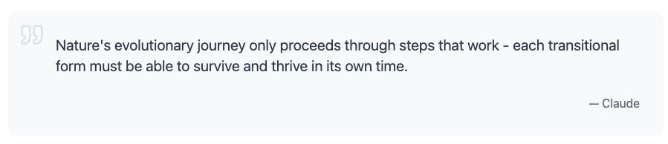

The above is equally true for product development. Each “phase” of the product should provide value to the users. Breaking product development into phases allows us to “close the loop” and quickly get feedback from users. Ensuring that we generate maximal value to our users. This is a tentative outline for the project:

**Phase 1: One shot ad generation**

Generate basic ads. Use fal or some other image gen api. Add a paywall obviously. Track which ones the user likes and which ones they don't. Use the context that we have on the user to offer ads to them. Put abuse and overuse safeguards. The ads can be pretty formulaic and follow templates, might need to do some research to see what other people are doing.

**Phase 2: Ad Editor**

Allow for more interactive, ad editing. Integrate the Ad editor with askbreezy somehow. Allow user to place text on the ads in a (WYSWYG kind of thing).

**Phase 3: Versatile Assets**

Support images of different aspect ratios and simple videos.

**Phase 4: Internal Integration**

Integrate with breezy sites and with breezy email.

**Phase 5: Automatic Agency**

Connect with google / yelp profile, facebook campaigns. Allow lunching and managing simple marketing campaigns from inside of Breezy. The campaigns should be integrated with breezy sites / the CRM.